**Assignment No- 4**

1) Write a program that demonstrates widening conversion from int to double and prints the result.

**package** org.example.wide;

**public** **class** Program {

**public** **static** **void** main(String[] args) {

**int** num1 = 1;

**double** num2 = num1;

System.***out***.println(num2);

}

}



2) Create a program that demonstrates narrowing conversion from double to int and prints the result.

**package org.example.narrow;**

**public class Program {**

**public static void main(String[] args) {**

**double num1 = 1.0d;**

**int num2 = (int) num1;**

**System.*out*.println(num2);**

**}**

**}**



3) Write a program that performs arithmetic operations involving different data types (int, double, float) and observes how Java handles widening conversions automatically.

**package** org.example.arithmetic;

**public** **class** Program {

**public** **static** **void** main(String[] args) {

**int** v1 = 10;

**double** v2 = 20.0d;

**float** v3 = 30.0f;

**double** addResult = v1 + v3;

System.***out***.println("Addition of int and float : "+addResult);

**double** mulResult1 = v1 - v3;

System.***out***.println("Subtraction of int and float : "+mulResult1);

**float** mulResult2 = v1 * v1;

System.***out***.println("Multiplication of int and double : "+mulResult2);

**double** divResult = v1 / v3;

System.***out***.println("Division between int and float"+divResult);

**double** mixedOperation = (v1 * v3) + v2;

System.***out***.println("Mixed Result : "+mixedOperation);

}

}

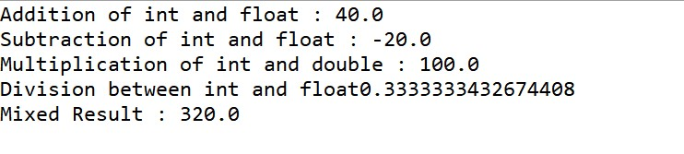

4) Write a Program that demonstrates widening conversion from int to (double,float, boolean, string) and prints the result.

**package** org.example.widening;

**public** **class** Program {

**public** **static** **void** main(String[] args) {

**int** value = 4;

**double** d = value;

**float** f = value;

// boolean b = value; //Not Possible

// String str = value; //Not Possible

System.***out***.println("Double : "+d+" \nFloat : "+f);

}

}



**Interview Questions**

1.What is the role of the static keyword in the context of memory management.

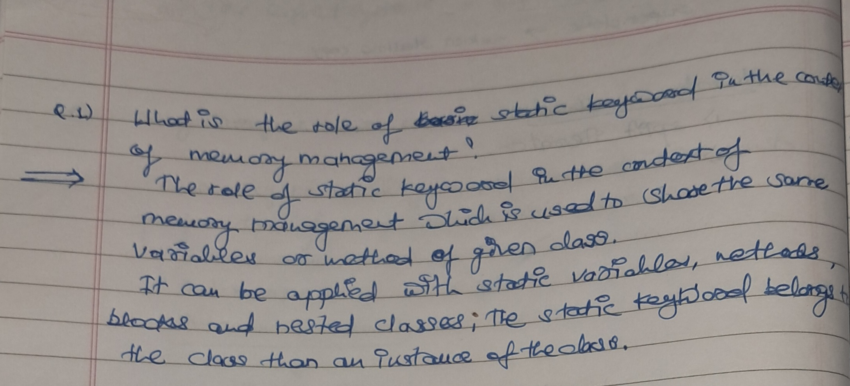

2.Can static methods be overloaded and overridden in Java?Howstatic variables shared across multiple instances of a class?

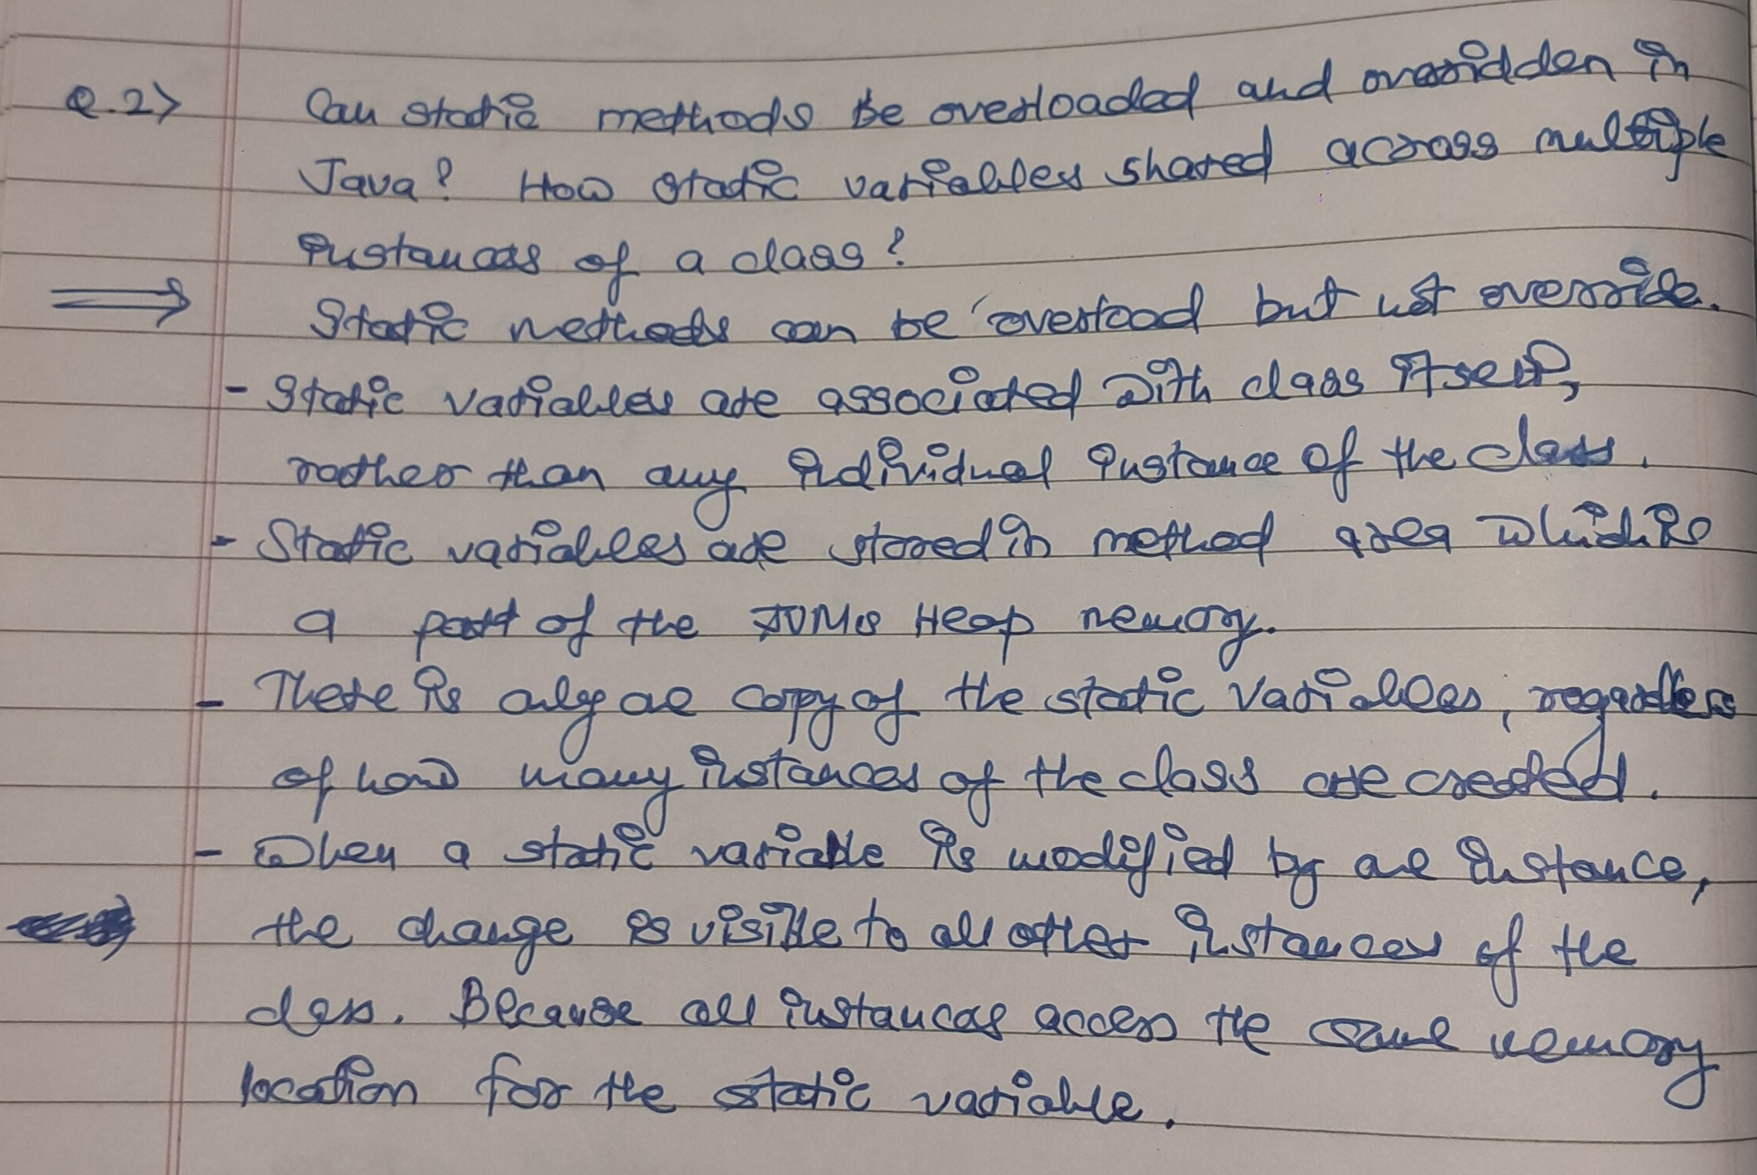

3.What is the significance of the final keyword in Java?

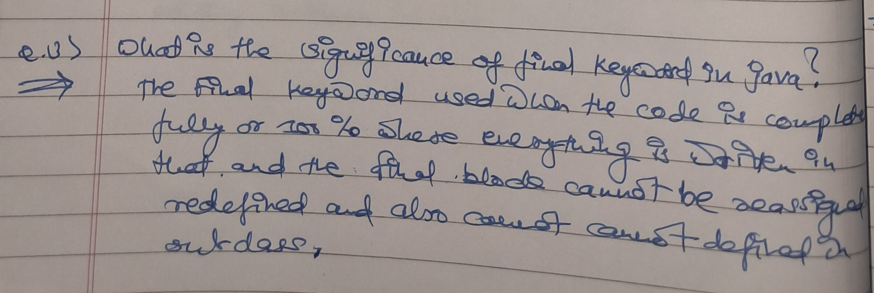

4.What are narrowing and widening conversions in Java?

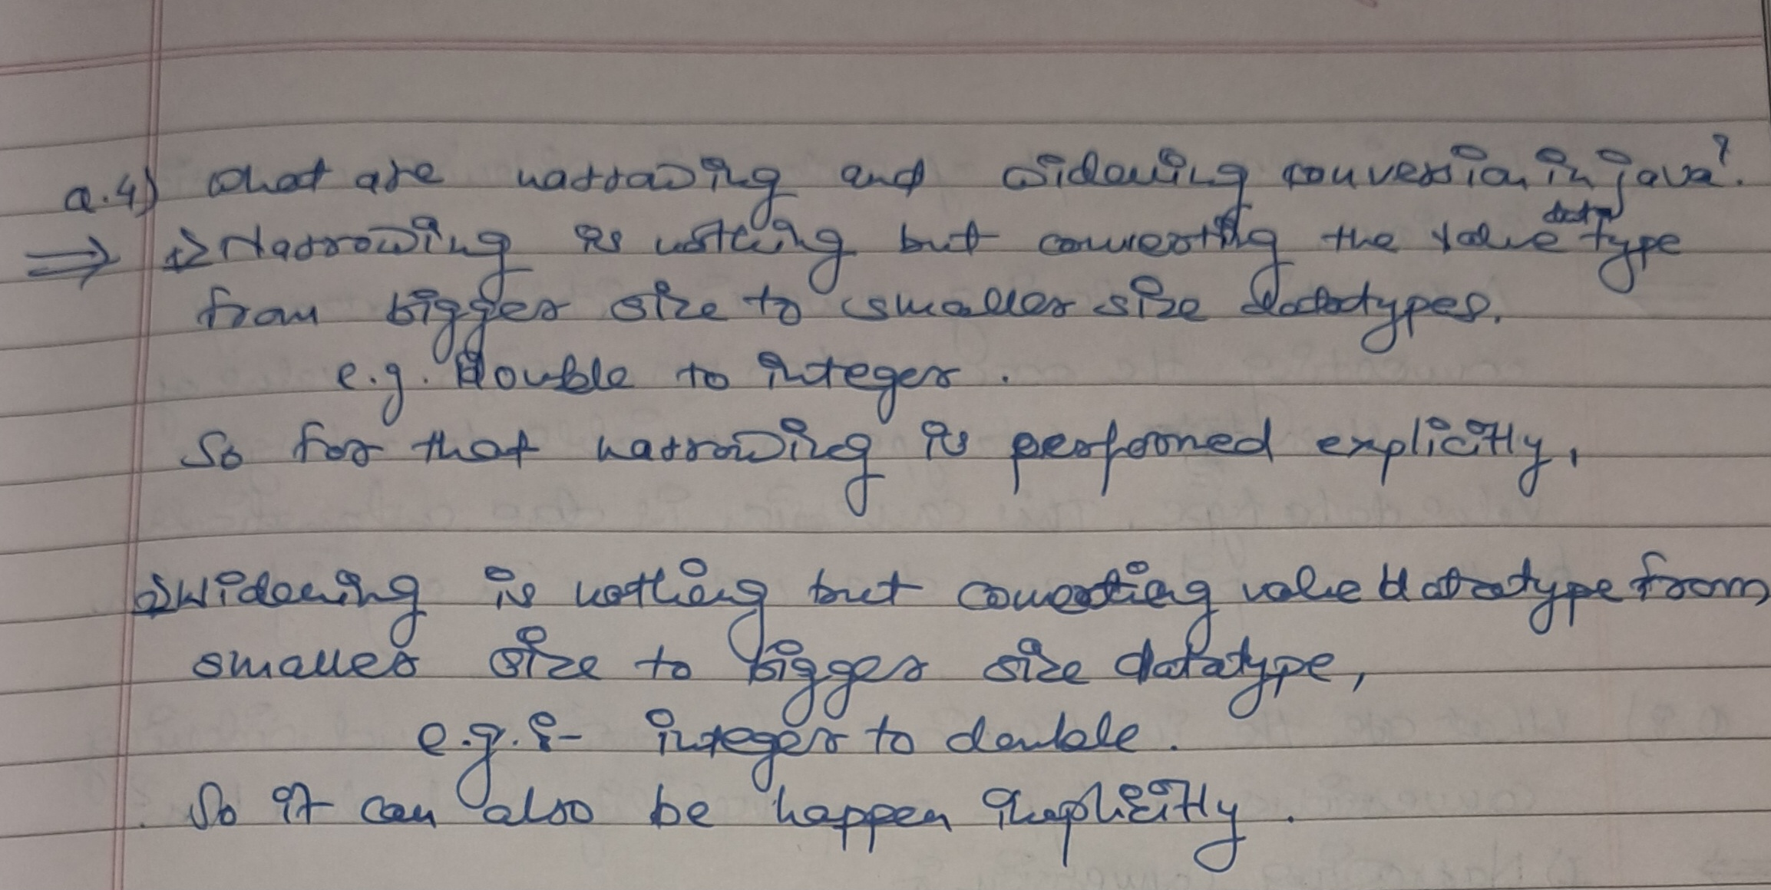

5.Provide examples of narrowing and widening conversions between primitive data types.

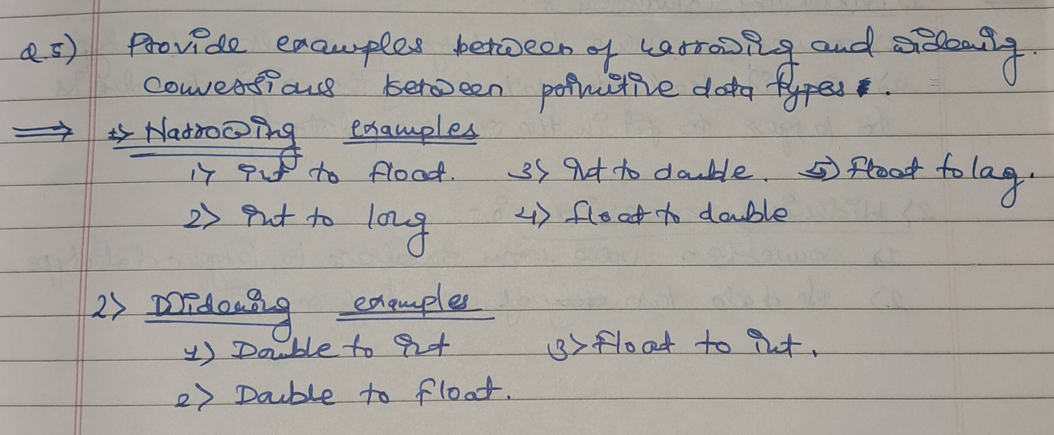

6.How does Java handle potential loss of precision during narrowing conversions?

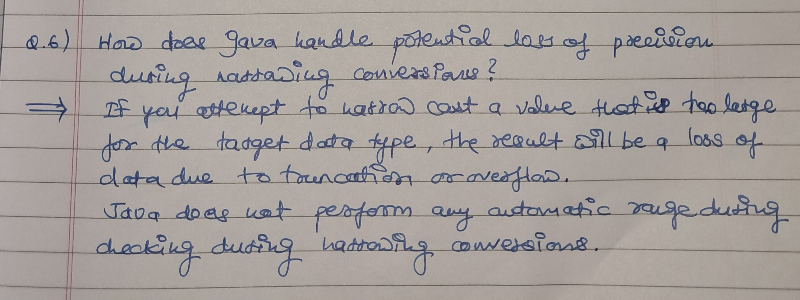

7.Explain the concept of automatic widening conversion in Java.

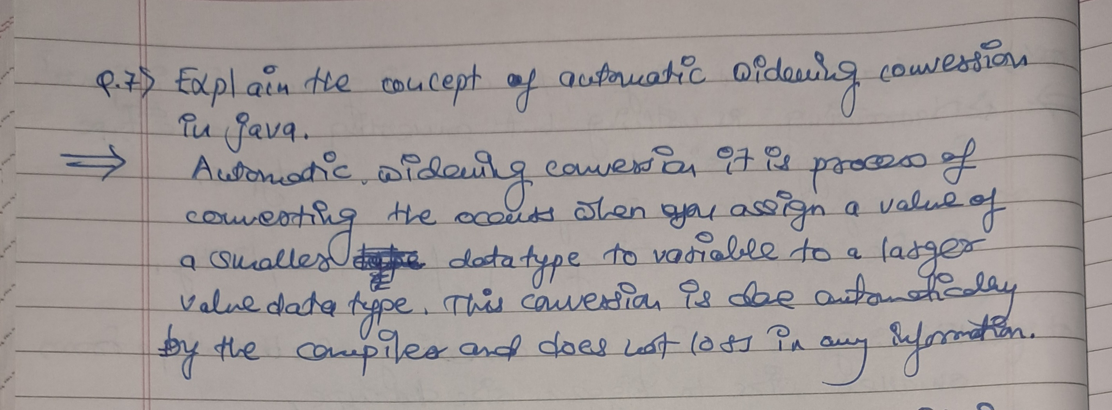

8. What are the implications of narrowing and widening conversions on type compatibility and data loss?

